April 14, 2020

Josh Metz
Executive Officer
Fort Ord Reuse Authority
920 2nd Ave., Suite A
Marina, CA 93933

Dear Mr. Metz:
CSU Monterey Bay submits the following edits, via two proposed motions, to the Administrative Committee (AC) for agenda item 6a - Draft Transition Plan Implementing Agreement (TPIA) Review and Recommendation, in advance of the 4/15/20 AC Zoom meeting.
Motion #1: Edit TPIA Section 2.0 Option A - https://fora.org/Admin/2020/Materials/3-11-20_DRAFT_TPIA_Water_Allocation_Language_Options.pdf as follows:

2.0 WATER ALLOCATIONS

Until such time as such allocations may be amended as provided herein, each of the Parties agrees to honor and abide by the allocations of potable and recycled water set forth in Exhibit A attached hereto, subject to compliance with all applicable laws including, but not limited to, the California Environmental Quality Act (Public Resources Code Section 21000 et seq.) and the Sustainable Groundwater Management Act (Water Code Section 10720 et seq.). In the event of a groundwater action, or increased availability of Army water such reductions or increases shall be taken proportionally in accordance with the percentages shown in the “Future Water Allocation” column of Exhibit A. Each of the Parties listed in Exhibit A may meet and confer in good faith to cooperatively develop one or more agreements between the Parties and/or Marina Coast Water District regarding the provision of potable and recycled water services to each of the Parties. The Parties acknowledge that MCWD has agreed to the water allocations in Exhibit A.

Motion #2: Add a footnote to Exhibit A to recognize the irrevocable allocation of water from the City of Marina to the Promontory, now owned by CSUMB, a Party that can hold a FORA water allocation in its own right:

Footnote to Table: City of Marina and CSUMB’s Potable Groundwater Allocation: The City of Marina’s Potable Groundwater Allocation is reduced 33.29 AFY to 1,307.7 AFY and the CSUMB Potable Groundwater Allocation is increased 33.29 AFY to 1,068 AFY pursuant to Marina City Council resolution 2013-86, FORA Board resolution 13-09 and MCWD Board resolution 2013-59 pertaining to The Promontory @ CSUMB Student Dormitory Housing Project subsequently acquired by CSUMB as successor and assign of AMCAL Equities, LLC.

The cited resolutions sent under separate cover for reference.

Exhibit A for Reference:
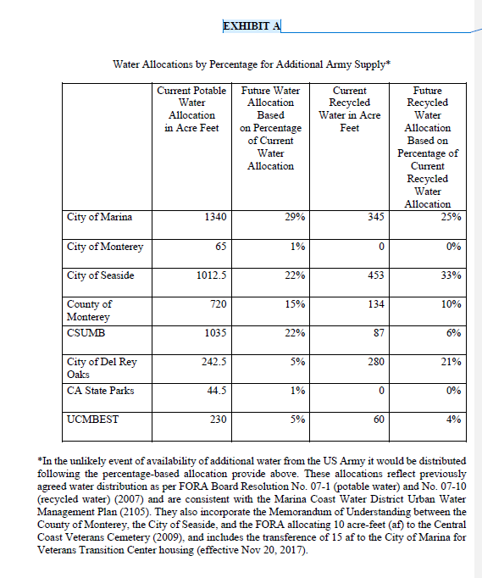
Thank you in advance for sharing these proposed motions to edit TPIA Section 2.0 with the AC before the 4/15/20 meeting.
Sincerely,

Anya Spear
CSU Monterey Bay
Associate Director of Campus Planning

